Modeling
-----------------
What is ‘Modeling’ and Why do we Need Models?
- Modeling’ involves developing a set of equations or mathematical formulation by which we can
    - predict certain events
    - identify the drivers of certain events
- based on a set of explanatory (or independent) variables.
- For example, if ‘Y’ is the event of application for an auto insurance and X₁, X₂,…., X_{n} correspond to drivers of ‘Y’ like, driver age, vehicle age, car age, Demographic factors, etc. then Y can be expressed as a function of X₁, X₂,….., X_{n} as follows:
Y = f( X ) = f(X₁, X₂, ….., X_{n})

- Where Y is called the dependent/ response variable and X_{i} is called the i ^{th} independent/ explanatory variable.
- Statistical models help in solving practical business problems.

Process of Predictive Modeling
Modeling is a combination of the science and Arts.
Most processes for creating predictive models incorporate the following steps
1. Project Definition / Business Understanding
Define business objectives and desired outcomes
2. Exploration / Data Understanding
Analyze source data to determine appropriate data, model building approach and scope
3. Data Preparation
Select, extract and transform data to create models
4. Model Building
Create, test and validate models, and evaluate them
5. Deployment
Apply model results to business decisions or processes
6. Model Management
Manage models to improve performance, accuracy, control access, promote reuse
Project Definition / Business Understanding

Define the Goal/objective
Possible Objectives or Goals of the Predictive Modeling
- Increase response rate
- Increase revenue
- Decrease mailing costs
- Increase profit
- Increase reactivation rate for dormant customers
- Increase order values
- Decrease product returns

Define the problem clearly
Predict the likelihood of churn in the next month for our 10% most valuable customers”
Define the solution clearly
Is this a one-time job, an on-going monthly batch job, or a real-time response (call centers and web)?
- What would the ideal result look like?
- How would it be used?

Introduction to Regression Analysis
Regression analysis is used to:
  - Predict the value of a dependent variable based on the value of at least one independent variable
  - Explain the impact of changes in an independent variable on the dependent variable
Dependent variable: the variable we wish to explain
Independent variable: the variable used to explain the dependent variable

Simple Linear Regression Model
- Only one independent variable, x
- Relationship between x and y is described by a linear function
- Changes in y are assumed to be caused by changes in x

Types of Regression Models
Positive Linear Relationship
Relationship NOT Linear
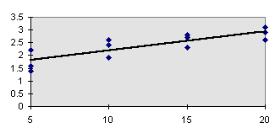
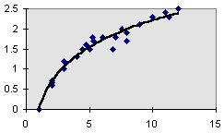

Negative Linear Relationship
No Relationship
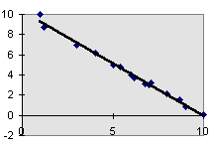
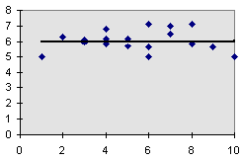

The Population Model
μy=β0+β1x, where μy is the population mean response, β0 is the y-intercept, and beta1 is the slope for the population model.
In our population, there could be many different responses for a value of x. In simple linear regression, the model assumes that for each value of x the observed values of the response variable y are normally distributed with a mean that depends on x. We use μy to represent these means. We also assume that these means all lie on a straight line when plotted against x (a line of means).
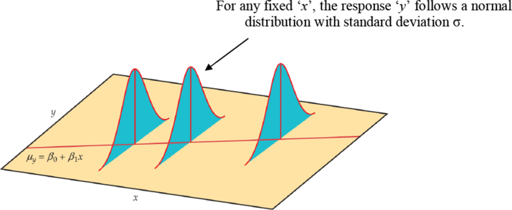
The statistical model for linear regression; the mean response is a straight-line function of the predictor variable.
The sample data then fit the statistical model:
Data = fit + residual
yi=(β0+β1xi)+ϵi
where the errors (εi) are independent and normally distributed N (0, σ). Linear regression also assumes equal variance of y (σ is the same for all values of x). We use ε (Greek epsilon) to stand for the residual part of the statistical model. A response y is the sum of its mean and chance deviation ε from the mean. The deviations ε represents the “noise” in the data. In other words, the noise is the variation in y due to other causes that prevent the observed (x, y) from forming a perfectly straight line.

Population Linear Regression

The population regression model
Population
y intercept
Random Error term, or residual
Population Slope
Coefficient
Independent Variable

Dependent Variable
Random Error
component
Linear component

Linear Regression Assumptions
- Error values (ε) are statistically independent
- Error values are normally distributed for any given value of x
- The probability distribution of the errors is normal
- The probability distribution of the errors has constant variance
- The underlying relationship between the x variable and the y variable is linear

Linear Regression

Steps to Build the Model
Step 1: Collect Data
Step 2: Explore & Prepare Data
Step 3: Train the Model
Step 4: Evaluate Model Performance
Step 5: Improve Model Performance

Business Context
Need to predict the medical expense
For a health insurance company to be profitable, it needs to gather more premium than it spends on medical care for its customers. So, it’s important for insurance companies to develop predictive models that forecast medical expenses for the insured people.
Our objective of using Linear Regression is to use historical patient data to estimate the average medical care expenses people.
These estimates can be used to create premium tables for a certain segment of people that can set the price of the premiums higher or lower depending on the expected treatment costs.

A Few Basics
- Covariance & Correlation
- Distribution – Gaussian Distribution – Skewness
- Normalization & Standardization
o Why transform?
o Min-Max Normalization
o Z-Score Standardization
- Dependent variable: the variable we wish to explain usually denoted by Y
- Independent variable(s): the variable(s) used to explain the dependent variable Denoted by X

Covariance & Correlation
Covariance is a measure of how changes in one variable are associated with changes in a second variable.
n
cov(X, Y)=Σ(Xi-X̅)(Yi-Y̅)
1
____________________________
n-1

Correlation is a scaled version of covariance that takes on values in [−1,1] with a correlation of ±1 indicating perfect linear association and 0 indicating no linear relationship.

ρ=cov(X, Y)
__________
σX⋅σy

Log Transformation
The log transformation can be used to make highly skewed distributions less skewed. This can be valuable both for making patterns in the data more interpretable and for helping to meet the assumptions of inferential statistics.

Another common form of transformations: Square, Square root transformation and Cube Transformation.

The math behind Linear Regression
There are two kinds of variables in a model:
1. The input or predictor variable, the one which helps predict the value of the output variable.
2. The output or response variable, the one which is predicted.

In the case of Linear Regression, we assume that Y (Expense) is a linear function of X (BMI) and to estimate Y, we write:

Y: The dependent variable (random variable)
X: Independent variable (not random variable)
β: Model Parameters
ε: Random Error, how the observation deviates from the population mean
SST(Sum of Squared Total)
Sum of Squared Total is the squared differences between the observed dependent variable and its average value(mean). One important note to be observed here is that we always compare our linear regression best fit line to the mean(denoted as y ̅ ) of the dependent variable slope.

Sum of Squared Total Error
Calculate how much error you would have if you don’t even try to do regression, and instead, just guess the mean of all the values. To get the total sum squared error, you start with the mean value. For every data, point subtract that mean value from the data point value. Square that difference and add up all the differences.
The distance between the blue dots and the mean value (brown line) is the error. Square that value for the squared error. Sum the squared error to get Sum of Squared Total Error. We will denote it with SST.

Sum of Regression Error
Calculate the error in your regression values against the true values. This is your regression error. We will denote it with SSE.

What is R-squared?
It is how much better your regression line is than a simple horizontal line through the mean of the data. In the diagram, the blue line denotes the data for which we are trying to generate a regression to, and the brown line is the average of that data. The brown line is the value that gives the lowest summed squared error to the blue data points, assuming you had no other information about the blue data points other than their y value.

R2 will be between 0 and 1. Closer to 1, better the model. A good R2 does not mean that the model is a very efficient one. May other factors need to be analyzed?
Another version of R2 is: R2=[corr(y,ŷ)]
R-squared is a statistical measure of how close the data are to the fitted regression line. It is also known as the coefficient of determination, or the coefficient of multiple determination for multiple regression. 0% indicates that the model explains none of the variability of the response data around its mean.

What is a good R-Squared value?
Lower the error in your regression analysis relative to total error, higher the R squared value. The best R squared value we get is 1.
To get R squared as 1, we need to have SSE i.e. SSregression be Zero.

Result Parameter: p-values
𝛂 & 𝞫 are estimates and not exact calculations. Whether the 𝞫 estimates are significant or not are tested using a hypothesis test. The hypothesis tests whether the value of are non-zero or not or in other words, if there is sufficient correlation between X and yact. If there is, the will be non-zero. In the equation, Y = 𝛂+ 𝞫X + 𝛆, if we put 𝞫 = 0, then there will be no relationship between y and x.
Ho: 𝞫i = 0; Ha: 𝞫i <> 0 for at least one i.
So when a regression task is performed, and 𝞫 is calculated, there will be an accompanying p-value. If the p -value is less than significance level, then the Ho is rejected and 𝞫 is taken to be significant and non-zero. The values of p-value larger than the significance level demonstrate that 𝞫 is not very significant in explaining the relationship between 2 variables.

F-Statistic
Result Parameter: F-Statistic
When one moves from single regression to multiple regression, there will be multiple 𝞫s and each of them will be an estimate. In that case, in addition to testing the significance of the individual variables in the model by checking the p-values associated with their estimation, it is also required to check whether, as a group all the predictors are significant or not.
This can be done using the following hypothesis:
Ho: 𝞫1 = 𝞫2 = 𝞫3 = 𝞫4 …= 𝞫i = 0; Ha: One of the 𝞫i <> 0
The statistic that is used to test the above hypothesis is called F-statistic; there will be a p-value associated with the F-Staistic and is defined as:
F-Statistic = (SST-SSE)/k ÷ SSE/(n-k-1)
Where n=number of observations, k=number of predictor variables.
When the number of predictors is very large, and all the 𝞫s are very close to 0, then if we rely solely on individual p-values, we might incorrectly conclude that there is relationship between the predictors and the outcome when it is not present actually. In such cases, we should look at the p-value associated with the F-Statistic.

Assumptions of Linear Regression
Assumption #1: One dependent variable that is measured at a continuous level
Assumption #2: Two or more independent variables that are measured either at the continuous or nominal level
Assumption #3: Independence of observations (Durbin-Watson test)
Assumption #4: There needs to be a linear relationship between the dependent variable and each of your independent variables (Scatter Plot)
Assumption #5: Data should not show heteroscedasticity (Breusch-Pagan test)
Assumption #6: Predictors must not show multicollinearity, i.e. the matrix would be a full rank matrix (VIF)
Assumption #7: There should be no significant outliers
Assumption #8: Check that the residuals (errors) are approximately normally distributed (Q-Q plot)
Heteroscedasticity (also spelled heteroskedasticity) refers to the circumstance in which the variability of a variable is unequal across the range of values of a second variable that predicts it.
Multicollinearity refers to a situation in which more than two explanatory variables in a multiple regression model are highly linearly related.

Autocorrelation – Durbin Watson Test
Error terms are independent of each other. Durbin Watson test uses the following statistic:
d takes on a value between 0 and 4. d should be close to 2 if there is no auto-correlation. A value substantially less that 2 means that the data is positively auto-correlated. A value substantially more than 2 means data is negatively auto-correlated.

Heteroscedasticity – Breusch Pagan Test
It tests whether the variance of the errors from regression is dependent on the values of the independent variables. In that case, heteroscedasticity is present. It assumes the heteroscedasticity is a linear function of the independent variables. Failing to find evidence of heteroscedasticity with the BP doesn’t rule out a nonlinear relationship between the independent variable(s) and the error variance. Additionally, the BP test isn’t useful for determining how to correct or adjust the model for heteroscedasticity.
Key Problems
There are two problems with linear regression.
• Multicollinearity
• Outliers

Diagnostic Plot – Residual Vs. Fitted

This is a simple scatter plot between residuals & predicted values. It should look more or less random and should not exhibit much distinctive pattern, no non-linear trends or changes in variability.

We see a clear trend in the residuals has a periodic trend. Unfortunately, the scatterplot smoother (red line) isn’t doing a good job here. Don’t always trust the red curve.

Diagnostic Plot – Normal Q-Q

This plot shows if the residuals a normally distributed. Residuals should be lined well on the straight dashed line. Case 2 is of definite concern, but Case 1 looks quite good as far normality is concerned.

Diagnostic Plot – Scale Location

This plot helps you check the assumption of equal variance (homoscedasticity). It’s good if you see a horizontal line with equally (randomly) spread points.

Case 1: Residuals appear randomly spread.
Case 2: Residuals spread wider & wider; the smooth red line is not horizontal and shows a steep angle.

Diagnostic Plot – Residuals vs. Leverage

This plot helps us find “Influential” cases. Not all outliers are influential. Even though data have extreme values, they might not be influential in determining a regression line. In other words, the results wouldn’t be much different if we either include or exclude them from the analysis. Look for outlying values at the upper right or lower right corner – cases outside of a dashed line, i.e. Cook’s Distance.

When cases are outside of the Cook’s distance (meaning they have high Cook’s distance scores), the cases are influential to the regression results. The regression results will be altered if we exclude those cases.

n statistics and in particular in regression analysis, leverage is a measure of how far away the independent variable values of an observation are from those of the other observations.

Cook’s Distance - Data points with large residuals (outliers) and/or high leverage may distort the outcome and accuracy of a regression. Cook's distance measures the effect of deleting a given observation. Points with a large Cook's distance are considered to merit closer examination in the analysis.

A step-by-step guide to linear regression in R
Linear regression is a regression model that uses a straight line to describe the relationship between variables. It finds the line of best fit through your data by searching for the value of the regression coefficient(s) that minimizes the total error of the model.There are two main types of linear regression:
- Simple linear regression uses only one independent variable
- Multiple linear regression uses two or more independent variables
Simple linear regression
The first dataset contains observations about income (in a range of $15k to $75k) and happiness (rated on a scale of 1 to 10) in an imaginary sample of 500 people. The income values are divided by 10,000 to make the income data match the scale of the happiness scores (so a value of $2 represents $20,000, $3 is $30,000, etc.)

Table of contents
- Getting started in R
- Load the data into R
- Make sure your data meet the assumptions
- Perform the linear regression analysis
- Check for homoscedasticity
- Visualize the results with a graph
- Report your results
To install the packages you need for the analysis, run this code
install.packages("ggplot2")
install.packages("dplyr")
install.packages("broom")
install.packages("ggpubr")
Next, load the packages into your R environment by running this code
library(ggplot2)
library(dplyr)
library(broom)
library(ggpubr)

Step 1: Load the data into R
Follow these four steps for each dataset:
- In RStudio, go to File > Import dataset > From Text (base).
- Choose the data file you have downloaded (income.data or heart.data), and an Import Dataset window pops up.
- In the Data Frame window, you should see an X (index) column and columns listing the data for each of the variables (income and happiness).
- Click on the Import button and the file should appear in your Environment tab on the upper right side of the RStudio screen.
After you’ve loaded the data, check that it has been read in correctly using summary().

Simple regression
summary(income.data)
Because both our variables are quantitative, when we run this function we see a table in our console with a numeric summary of the data. This tells us the minimum, median, mean, and maximum values of the independent variable (income) and dependent variable (happiness):
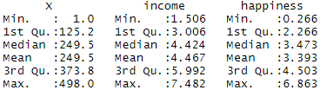

Step 2: Make sure your data meet the assumptions
We can use R to check that our data meet the four main assumptions for linear regression.

Simple regression
- Independence of observations (aka no autocorrelation)
Because we only have one independent variable and one dependent variable, we don’t need to test for any hidden relationships among variables.
If you know that you have autocorrelation within variables (i.e. multiple observations of the same test subject), then do not proceed with a simple linear regression! Use a structured model, like a linear mixed-effects model, instead.
- Normality
To check whether the dependent variable follows a normal distribution, use the hist() function.
hist(income.data$happiness)
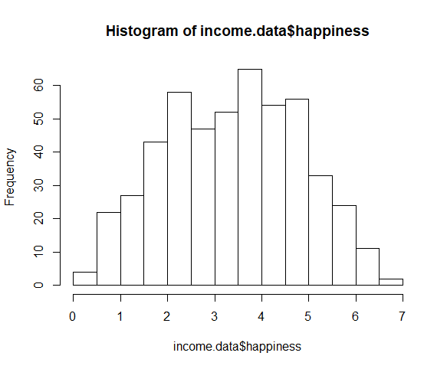
The observations are roughly bell-shaped (more observations in the middle of the distribution, fewer on the tails), so we can proceed with the linear regression.
- Linearity
The relationship between the independent and dependent variable must be linear. We can test this visually with a scatter plot to see if the distribution of data points could be described with a straight line.
plot(happiness ~ income, data = income.data)
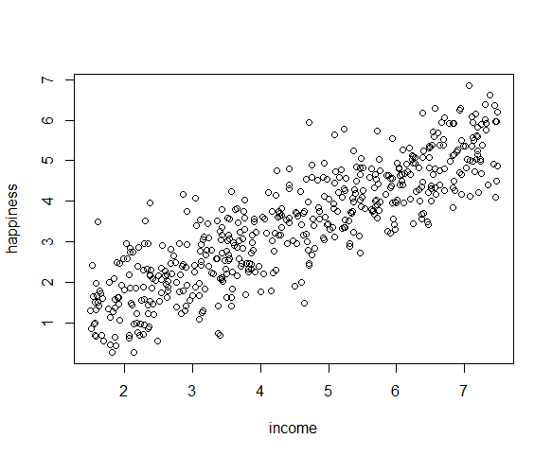
The relationship looks roughly linear, so we can proceed with the linear model.
- Homoscedasticity (aka homogeneity of variance)
This means that the prediction error doesn’t change significantly over the range of prediction of the model. We can test this assumption later, after fitting the linear model.

Step 3: Perform the linear regression analysis
Now that you’ve determined your data meet the assumptions, you can perform a linear regression analysis to evaluate the relationship between the independent and dependent variables.

Simple regression: income and happiness
Let’s see if there’s a linear relationship between income and happiness in our survey of 500 people with incomes ranging from $15k to $75k, where happiness is measured on a scale of 1 to 10.
To perform a simple linear regression analysis and check the results, you need to run two lines of code. The first line of code makes the linear model, and the second line prints out the summary of the model:
income.happiness.lm <- lm(happiness ~ income, data = income.data)

summary(income.happiness.lm)

The output looks like this:
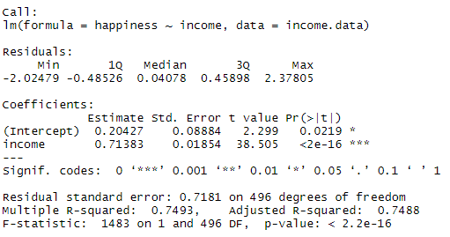
This output table first presents the model equation, then summarizes the model residuals (see step 4).
The Coefficients section shows:
- The estimates (Estimate) for the model parameters – the value of the y-intercept (in this case 0.204) and the estimated effect of income on happiness (0.713).
- The standard error of the estimated values (Std. Error).
- The test statistic (t value, in this case the t-statistic).
- The p-value ( Pr(>| t | ) ), aka the probability of finding the given t-statistic if the null hypothesis of no relationship were true.
The final three lines are model diagnostics – the most important thing to note is the p-value (here it is 2.2e-16, or almost zero), which will indicate whether the model fits the data well.
From these results, we can say that there is a significant positive relationship between income and happiness (p-value < 0.001), with a 0.713-unit (+/- 0.01) increase in happiness for every unit increase in income.
A residual is the vertical distance between a data point and the regression line. ... In other words, the residual is the error that isn't explained by the regression line. The residual(e) can also be expressed with an equation. The e is the difference between the predicted value (ŷ) and the observed value.

Step 4: Check for homoscedasticity
Before proceeding with data visualization, we should make sure that our models fit the homoscedasticity assumption of the linear model.

Simple regression
We can run plot(income.happiness.lm) to check whether the observed data meets our model assumptions:
par(mfrow=c(2,2))
plot(income.happiness.lm)
par(mfrow=c(1,1))
Note that the par(mfrow()) command will divide the Plots window into the number of rows and columns specified in the brackets. So par(mfrow=c(2,2)) divides it up into two rows and two columns. To go back to plotting one graph in the entire window, set the parameters again and replace the (2,2) with (1,1).
These are the residual plots produced by the code:
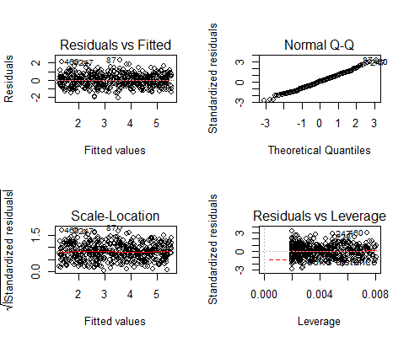
Residuals are the unexplained variance. They are not exactly the same as model error, but they are calculated from it, so seeing a bias in the residuals would also indicate a bias in the error.
The most important thing to look for is that the red lines representing the mean of the residuals are all basically horizontal and centered around zero. This means there are no outliers or biases in the data that would make a linear regression invalid.
In the Normal Q-Qplot in the top right, we can see that the real residuals from our model form an almost perfectly one-to-one line with the theoretical residuals from a perfect model.
Based on these residuals, we can say that our model meets the assumption of homoscedasticity.

Step 5: Visualize the results with a graph
Next, we can plot the data and the regression line from our linear regression model so that the results can be shared.

Simple regression
Follow 4 steps to visualize the results of your simple linear regression.
- Plot the data points on a graph (Scatter Plot)

income.graph<-ggplot(income.data, aes(x=income, y=happiness))+
geom_point()
income.graph
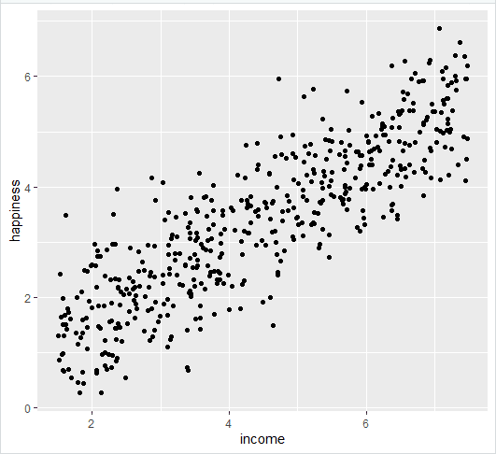
- Add the linear regression line to the plotted data
Add the regression line using geom_smooth() and typing in lm as your method for creating the line. This will add the line of the linear regression as well as the standard error of the estimate (in this case +/- 0.01) as a light grey stripe surrounding the line:

income.graph <- income.graph + geom_smooth(method="lm", col="black")

income.graph
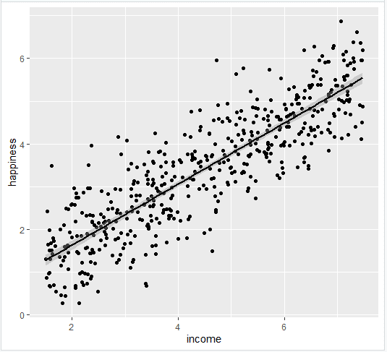
- Add the equation for the regression line.

income.graph <- income.graph +
stat_regline_equation(label.x = 3, label.y = 7)

income.graph
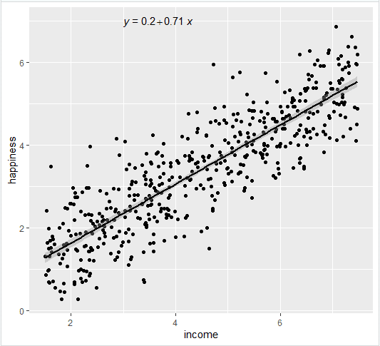
- Make the graph ready for publication
We can add some style parameters using theme_bw() and making custom labels using labs().

income.graph +
theme_bw() +
labs(title = "Reported happiness as a function of income",
x = "Income (x$10,000)",
y = "Happiness score (0 to 10)")
This produces the finished graph that you can include in your papers:

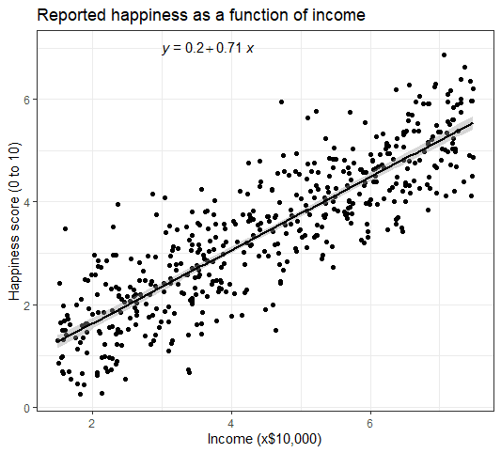

Step 6: Report your results
In addition to the graph, include a brief statement explaining the results of the regression model.
Reporting the results of simple linear regression
We found a significant relationship between income and happiness (p < 0.001, R2 = 0.73 ± 0.0193), with a 0.73-unit increase in reported happiness for every $10,000 increase in income.
Heteroscedasticity
The word “heteroscedasticity” comes from the Greek, and quite literally means data with a different (hetero) dispersion (skedasis). In simple terms, heteroscedasticity is any set of data that isn’t homoscedastic. More technically, it refers to data with unequal variability (scatter) across a set of second, predictor variables.

Heteroscedastic data tends to follow a cone shape on a scatter graph.
Why do we care about whether or not data is heteroscedastic? Most of the time in statistics, we don’t care. But if you’re running any kind of regression analysis, having data that shows heteroscedasticity can ruin your results (at the very least, it will give you biased coefficients). Therefore, you’ll want to check to make sure your data doesn’t have this condition. One way to check is to make a scatter graph (which is always a good idea when you’re running regression anyway). If your graph has a rough cone shape (like the one above), you’re probably dealing with heteroscedasticity. You can still run regression analysis, but you won’t get decent results.
Example -2
The cars dataset gives Speed and Stopping Distances of Cars. This dataset is a data frame with 50 rows and 2 variables. The rows refer to cars and the variables refer to speed (the numeric Speed in mph) and dist (the numeric stopping distance in ft.). As the summary output above shows, the cars dataset’s speed variable varies from cars with speed of 4 mph to 25 mph (the data source mentions these are based on cars from the ’20s! - to find out more about the dataset, you can type ?cars). When it comes to distance to stop, there are cars that can stop in 2 feet and cars that need 120 feet to come to a stop.
Below is a scatterplot of the variables:
plot(cars, col='blue', pch=20, cex=2, main="Relationship between Speed and Stopping Distance for 50 Cars",xlab="Speed in mph", ylab="Stopping Distance in feet")

From the plot above, we can visualise that there is a somewhat strong relationship between a cars’ speed and the distance required for it to stop (i.e.: the faster the car goes the longer the distance it takes to come to a stop).
In this exercise, we will:
- Run a simple linear regression model in R and distil and interpret the key components of the R linear model output. Note that for this example we are not too concerned about actually fitting the best model but we are more interested in interpreting the model output - which would then allow us to potentially define next steps in the model building process.

The set.seed() function sets the starting number used to generate a sequence of random numbers – it ensures that you get the same result if you start with that same seed each time you run the same process. For example, if I use the sample() function immediately after setting a seed, I will always get the same sample.

set.seed(1)
sample(3)

Standardization / Scaling
The concept of standardization comes into picture when continuous independent variables are measured at different scales. It means these variables do not give equal contribution to the analysis. For example, we are performing customer segmentation analysis in which we are trying to group customers based on their homogenous (similar) attributes. A variable called 'transaction amount' that ranges between $100 and $10000 carries more weightage as compared to a variable i.e. number of transactions that in general ranges between 0 and 30. Hence, it is required to transform the data to comparable scales. The idea is to rescale an original variable to have equal range and/or variance.

In scale() function, center= TRUE implies subtracting the mean from its original variable. The scale = TRUE implies dividing the centered column by its standard deviations.

scale , with default settings, will calculate the mean and standard deviation of the entire vector, then "scale" each element by those values by subtracting the mean and dividing by the sd. (If you use scale(x, scale=FALSE) , it will only subtract the mean but not divide by the std deviation.)

Example-
mt <- matrix(1:10, ncol = 5)
mt
scale(mt,center = TRUE,scale = FALSE)

set.seed(122)
speed.c = scale(cars$speed, center=TRUE, scale=FALSE)
mod1 = lm(formula = dist ~ speed.c, data = cars)
summary(mod1)
The model above is achieved by using the lm() function in R and the output is called using the summary() function on the model.
Below we define and briefly explain each component of the model output:
Formula Call
As you can see, the first item shown in the output is the formula R used to fit the data. Note the simplicity in the syntax: the formula just needs the predictor (speed) and the target/response variable (dist), together with the data being used (cars).
Residuals
The next item in the model output talks about the residuals. Residuals are essentially the difference between the actual observed response values (distance to stop dist in our case) and the response values that the model predicted. The Residuals section of the model output breaks it down into 5 summary points. When assessing how well the model fit the data, you should look for a symmetrical distribution across these points on the mean value zero (0). In our example, we can see that the distribution of the residuals do not appear to be strongly symmetrical. That means that the model predicts certain points that fall far away from the actual observed points. We could take this further consider plotting the residuals to see whether this normally distributed, etc. but will skip this for this example.
Coefficients
The next section in the model output talks about the coefficients of the model. Theoretically, in simple linear regression, the coefficients are two unknown constants that represent the intercept and slope terms in the linear model. If we wanted to predict the Distance required for a car to stop given its speed, we would get a training set and produce estimates of the coefficients to then use it in the model formula. Ultimately, the analyst wants to find an intercept and a slope such that the resulting fitted line is as close as possible to the 50 data points in our data set.
Coefficient - Estimate
The coefficient Estimate contains two rows; the first one is the intercept. The intercept, in our example, is essentially the expected value of the distance required for a car to stop when we consider the average speed of all cars in the dataset. In other words, it takes an average car in our dataset 42.98 feet to come to a stop. The second row in the Coefficients is the slope, or in our example, the effect speed has in distance required for a car to stop. The slope term in our model is saying that for every 1 mph increase in the speed of a car, the required distance to stop goes up by 3.9324088 feet.
Coefficient - Standard Error
The coefficient Standard Error measures the average amount that the coefficient estimates vary from the actual average value of our response variable. We’d ideally want a lower number relative to its coefficients. In our example, we’ve previously determined that for every 1 mph increase in the speed of a car, the required distance to stop goes up by 3.9324088 feet. The Standard Error can be used to compute an estimate of the expected difference in case we ran the model again and again. In other words, we can say that the required distance for a car to stop can vary by 0.4155128 feet. The Standard Errors can also be used to compute confidence intervals and to statistically test the hypothesis of the existence of a relationship between speed and distance required to stop.
Coefficient - t value
The coefficient t-value is a measure of how many standard deviations our coefficient estimate is far away from 0. We want it to be far away from zero as this would indicate we could reject the null hypothesis - that is, we could declare a relationship between speed and distance exist. In our example, the t-statistic values are relatively far away from zero and are large relative to the standard error, which could indicate a relationship exists. In general, t-values are also used to compute p-values.
Coefficient - Pr(>t)
The Pr(>t) acronym found in the model output relates to the probability of observing any value equal or larger than t. A small p-value indicates that it is unlikely we will observe a relationship between the predictor (speed) and response (dist) variables due to chance. Typically, a p-value of 5% or less is a good cut-off point. In our model example, the p-values are very close to zero. Note the ‘signif. Codes’ associated to each estimate. Three stars (or asterisks) represent a highly significant p-value. Consequently, a small p-value for the intercept and the slope indicates that we can reject the null hypothesis which allows us to conclude that there is a relationship between speed and distance.
Residual Standard Error
Residual Standard Error is measure of the quality of a linear regression fit. Theoretically, every linear model is assumed to contain an error term E. Due to the presence of this error term, we are not capable of perfectly predicting our response variable (dist) from the predictor (speed) one. The Residual Standard Error is the average amount that the response (dist) will deviate from the true regression line. In our example, the actual distance required to stop can deviate from the true regression line by approximately 15.3795867 feet, on average. In other words, given that the mean distance for all cars to stop is 42.98 and that the Residual Standard Error is 15.3795867, we can say that the percentage error is (any prediction would still be off by) 35.78%. It’s also worth noting that the Residual Standard Error was calculated with 48 degrees of freedom. Simplistically, degrees of freedom are the number of data points that went into the estimation of the parameters used after taking into account these parameters (restriction). In our case, we had 50 data points and two parameters (intercept and slope).
Multiple R-squared, Adjusted R-squared
The R-squared (R²) statistic provides a measure of how well the model is fitting the actual data. It takes the form of a proportion of variance. R² is a measure of the linear relationship between our predictor variable (speed) and our response / target variable (dist). It always lies between 0 and 1 (i.e.: a number near 0 represents a regression that does not explain the variance in the response variable well and a number close to 1 does explain the observed variance in the response variable). In our example, the R² we get is 0.6510794. Or roughly 65% of the variance found in the response variable (dist) can be explained by the predictor variable (speed). Step back and think: If you were able to choose any metric to predict distance required for a car to stop, would speed be one and would it be an important one that could help explain how distance would vary based on speed? I guess it’s easy to see that the answer would almost certainly be a yes. That why we get a relatively strong R². Nevertheless, it’s hard to define what level of R² is appropriate to claim the model fits well. Essentially, it will vary with the application and the domain studied.
note: In multiple regression settings, the R² will always increase as more variables are included in the model. That’s why the adjusted R² is the preferred measure as it adjusts for the number of variables considered.
F-Statistic
F-statistic is a good indicator of whether there is a relationship between our predictor and the response variables. The further the F-statistic is from 1 the better it is. However, how much larger the F-statistic needs to be depends on both the number of data points and the number of predictors. Generally, when the number of data points is large, an F-statistic that is only a little bit larger than 1 is already sufficient to reject the null hypothesis (H0 : There is no relationship between speed and distance). The reverse is true as if the number of data points is small, a large F-statistic is required to be able to ascertain that there may be a relationship between predictor and response variables. In our example the F-statistic is 89.5671065 which is relatively larger than 1 given the size of our data.
Note that the model we ran above was just an example to illustrate how a linear model output looks like in R and how we can start to interpret its components.

An introduction to multiple linear regression
Regression models are used to describe relationships between variables by fitting a line to the observed data. Regression allows you to estimate how a dependent variable changes as the independent variable(s) change.
Multiple linear regression is used to estimate the relationship between two or more independent variables and one dependent variable. You can use multiple linear regression when you want to know:
- How strong the relationship is between two or more independent variables and one dependent variable (e.g. how rainfall, temperature, and amount of fertilizer added affect crop growth).
- The value of the dependent variable at a certain value of the independent variables (e.g. the expected yield of a crop at certain levels of rainfall, temperature, and fertilizer addition).

Example
You are a public health researcher interested in social factors that influence heart disease. You survey 500 towns and gather data on the percentage of people in each town who smoke, the percentage of people in each town who bike to work, and the percentage of people in each town who have heart disease.
Because you have two independent variables and one dependent variable, and all your variables are quantitative, you can use multiple linear regression to analyze the relationship between them.

Table of contents
- Assumptions of multiple linear regression
- How to perform a multiple linear regression
- Interpreting the results
- Presenting the results

Assumptions of multiple linear regression
Multiple linear regression makes all of the same assumptions as simple linear regression:
Homogeneity of variance (homoscedasticity): the size of the error in our prediction doesn’t change significantly across the values of the independent variable.
Independence of observations: the observations in the dataset were collected using statistically valid methods, and there are no hidden relationships among variables.
In multiple linear regression, it is possible that some of the independent variables are actually correlated with one another, so it is important to check these before developing the regression model. If two independent variables are too highly correlated (r2 > ~0.6), then only one of them should be used in the regression model.
Normality: The data follows a normal distribution.
Linearity: the line of best fit through the data points is a straight line, rather than a curve or some sort of grouping factor.

How to perform a multiple linear regression

Multiple linear regression formula
The formula for a multiple linear regression is:
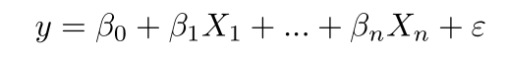
- y = the predicted value of the dependent variable
- B₀ = the y-intercept (value of y when all other parameters are set to 0)
- B₁X₁= the regression coefficient (B₁) of the first independent variable (X₁) (a.k.a. the effect that increasing the value of the independent variable has on the predicted y value)
- … = do the same for however many independent variables you are testing
- B_{n}X_{n} = the regression coefficient of the last independent variable
- e = model error (a.k.a. how much variation there is in our estimate of y)
To find the best-fit line for each independent variable, multiple linear regression calculates three things:
- The regression coefficients that lead to the smallest overall model error.
- The t-statistic of the overall model.
- The associated p-value (how likely it is that the t-statistic would have occurred by chance if the null hypothesis of no relationship between the independent and dependent variables was true).
It then calculates the t-statistic and p-value for each regression coefficient in the model.
Load the heart.data dataset into your R environment and run the following code:
Heart.data<-read.csv(“”)
summary(heart.data)
Again, because the variables are quantitative, running the code produces a numeric summary of the data for the independent variables (smoking and biking) and the dependent variable (heart disease):
- Independence of observations (aka no autocorrelation)
Use the cor() function to test the relationship between your independent variables and make sure they aren’t too highly correlated.
cor(heart.data$biking, heart.data$smoking)
When we run this code, the output is 0.015. The correlation between biking and smoking is small (0.015 is only a 1.5% correlation), so we can include both parameters in our model.
- Normality
Use the hist() function to test whether your dependent variable follows a normal distribution.
hist(heart.data$heart.disease)
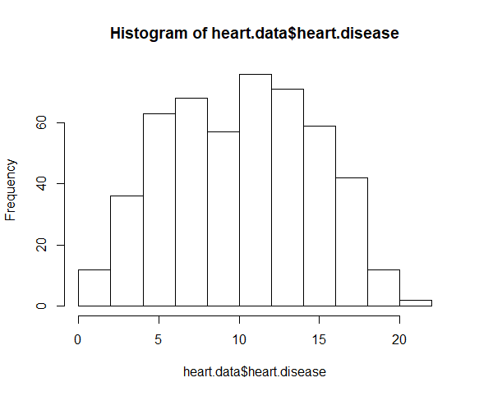
The distribution of observations is roughly bell-shaped, so we can proceed with the linear regression.
- Linearity
We can check this using two scatterplots: one for biking and heart disease, and one for smoking and heart disease.
plot(heart.disease ~ biking, data=heart.data)
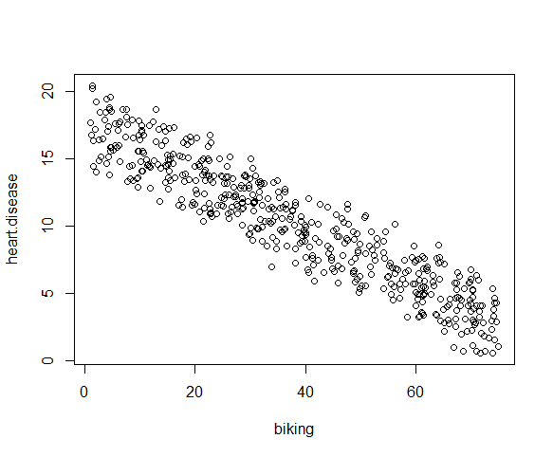

plot(heart.disease ~ smoking, data=heart.data)
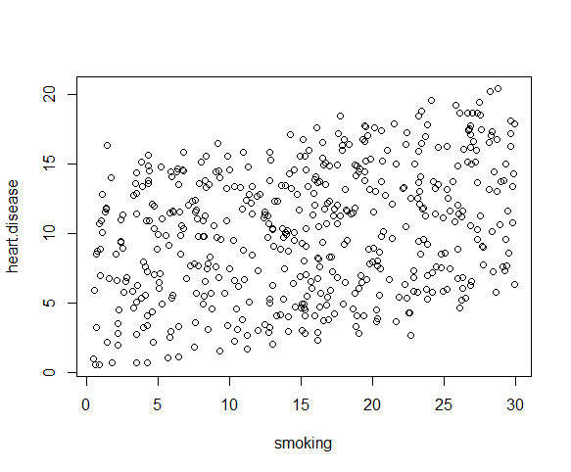
Although the relationship between smoking and heart disease is a bit less clear, it still appears linear. We can proceed with linear regression.
- Homoscedasticity
We will check this after we make the model.

Multiple regression: biking, smoking, and heart disease
Let’s see if there’s a linear relationship between biking to work, smoking, and heart disease in our imaginary survey of 500 towns. The rates of biking to work range between 1 and 75%, rates of smoking between 0.5 and 30%, and rates of heart disease between 0.5% and 20.5%.
To test the relationship, we first fit a linear model with heart disease as the dependent variable and biking and smoking as the independent variables. Run these two lines of code:
heart.disease.lm<-lm(heart.disease ~ biking + smoking, data = heart.data)’
summary(heart.disease.lm)

This code takes the data set heart.data and calculates the effect that the independent variables biking and smoking have on the dependent variable heart disease using the equation for the linear model: lm().
The estimated effect of biking on heart disease is -0.2, while the estimated effect of smoking is 0.178.
This means that for every 1% increase in biking to work, there is a correlated 0.2% decrease in the incidence of heart disease. Meanwhile, for every 1% increase in smoking, there is a 0.178% increase in the rate of heart disease.
The standard errors for these regression coefficients are very small, and the t-statistics are very large (-147 and 50.4, respectively). The p-values reflect these small errors and large t-statistics. For both parameters, there is almost zero probability that this effect is due to chance.

Interpreting the results
To view the results of the model, you can use the summary() function:
summary(heart.disease.lm)

This function takes the most important parameters from the linear model and puts them into a table that looks like this:
The summary first prints out the formula (‘Call’), then the model residuals (‘Residuals’). If the residuals are roughly centered around zero and with similar spread on either side, as these do (median 0.03, and min and max around -2 and 2) then the model probably fits the assumption of heteroscedasticity.
Next are the regression coefficients of the model (‘Coefficients’). Row 1 of the coefficients table is labeled (Intercept) – this is the y-intercept of the regression equation. It’s helpful to know the estimated intercept in order to plug it into the regression equation and predict values of the dependent variable:
heart disease = 15 + (-0.2*biking) + (0.178*smoking) ± e

The most important things to note in this output table are the next two tables – the estimates for the independent variables.
The Estimate column is the estimated effect, also called the regression coefficient or r² value. The estimates in the table tell us that for every one percent increase in biking to work there is an associated 0.2 percent decrease in heart disease, and that for every one percent increase in smoking there is an associated .17 percent increase in heart disease.
The Std.error column displays the standard error of the estimate. This number shows how much variation there is around the estimates of the regression coefficient.
The t value column displays the test statistic. Unless otherwise specified, the test statistic used in linear regression is the t-value from a two-sided t-test. The larger the test statistic, the less likely it is that the results occurred by chance.
The Pr( > | t | ) column shows the p-value. This shows how likely the calculated t-value would have occurred by chance if the null hypothesis of no effect of the parameter were true.
Because these values are so low (p < 0.001 in both cases), we can reject the null hypothesis and conclude that both biking to work and smoking both likely influence rates of heart disease

Step 4: Check for homoscedasticity
Before proceeding with data visualization, we should make sure that our models fit the homoscedasticity assumption of the linear model.
Again, we should check that our model is actually a good fit for the data, and that we don’t have large variation in the model error, by running this code:
par(mfrow=c(2,2))
plot(heart.disease.lm)
par(mfrow=c(1,1))
The output looks like this:
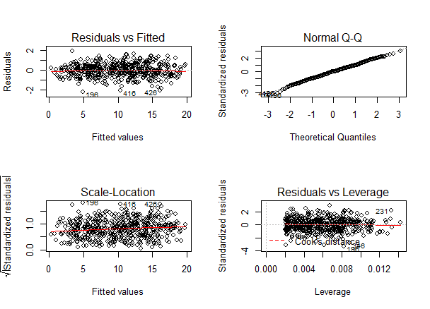
As with our simple regression, the residuals show no bias, so we can say our model fits the assumption of homoscedasticity.
.

Presenting the results
When reporting your results, include the estimated effect (i.e. the regression coefficient), the standard error of the estimate, and the p-value. You should also interpret your numbers to make it clear to your readers what the regression coefficient means.
In our survey of 500 towns, we found significant relationships between the frequency of biking to work and the frequency of heart disease and the frequency of smoking and frequency of heart disease (p < 0.001 for each). Specifically we found a 0.2% decrease (± 0.0014) in the frequency of heart disease for every 1% increase in biking, and a 0.178% increase (± 0.0035) in the frequency of heart disease for every 1% increase in smoking.

Step 5: Visualize the results with a graph
It can also be helpful to include a graph with your results. Multiple linear regression is somewhat more complicated than simple linear regression, because there are more parameters than will fit on a two-dimensional plot.
However, there are ways to display your results that include the effects of multiple independent variables on the dependent variable, even though only one independent variable can actually be plotted on the x-axis.
The visualization step for multiple regression is more difficult than for simple regression, because we now have two predictors. One option is to plot a plane, but these are difficult to read and not often published.
We will try a different method: plotting the relationship between biking and heart disease at different levels of smoking. In this example, smoking will be treated as a factor with three levels, just for the purposes of displaying the relationships in our data.
There are 7 steps to follow.
- Create a new dataframe with the information needed to plot the model
Use the function expand.grid() to create a dataframe with the parameters you supply. Within this function we will:
- Create a sequence from the lowest to the highest value of your observed biking data;
- Choose the minimum, mean, and maximum values of smoking, in order to make 3 levels of smoking over which to predict rates of heart disease.
plotting.data<-expand.grid(
biking = seq(min(heart.data$biking), max(heart.data$biking), length.out=30),
smoking=c(min(heart.data$smoking), mean(heart.data$smoking), max(heart.data$smoking)))
This will not create anything new in your console, but you should see a new data frame appear in the Environment tab. Click on it to view it.
- Predict the values of heart disease based on your linear model
Next we will save our ‘predicted y’ values as a new column in the dataset we just created.
plotting.data$predicted.y <- predict.lm(heart.disease.lm, newdata=plotting.data)
- Round the smoking numbers to two decimals
This will make the legend easier to read later on.
plotting.data$smoking <- round(plotting.data$smoking, digits = 2)
- Change the ‘smoking’ variable into a factor
This allows us to plot the interaction between biking and heart disease at each of the three levels of smoking we chose.
plotting.data$smoking <- as.factor(plotting.data$smoking)
- Plot the original data
heart.plot <- ggplot(heart.data, aes(x=biking, y=heart.disease)) +
geom_point()

heart.plot

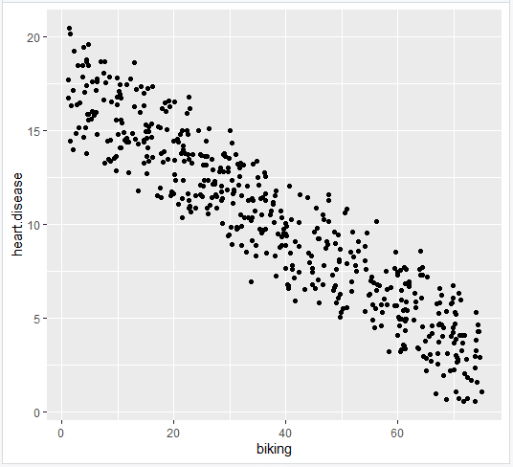
Here, we have calculated the predicted values of the dependent variable (heart disease) across the full range of observed values for the percentage of people biking to work.
To include the effect of smoking on the independent variable, we calculated these predicted values while holding smoking constant at the minimum, mean, and maximum observed rates of smoking.
- Add the regression lines
heart.plot <- heart.plot +
geom_line(data=plotting.data, aes(x=biking, y=predicted.y, color=smoking), size=1.25)

heart.plot
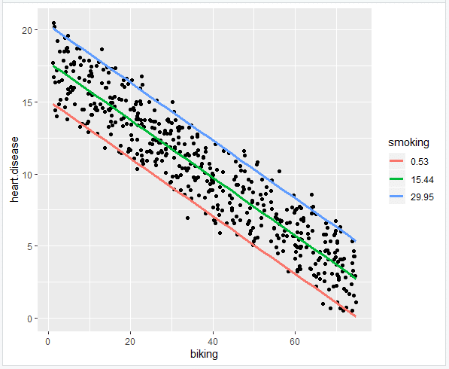
- Make the graph ready for publication
heart.plot <-
heart.plot +
theme_bw() +
labs(title = "Rates of heart disease (% of population) \n as a function of biking to work and smoking",
x = "Biking to work (% of population)",
y = "Heart disease (% of population)",
color = "Smoking \n (% of population)")

heart.plot
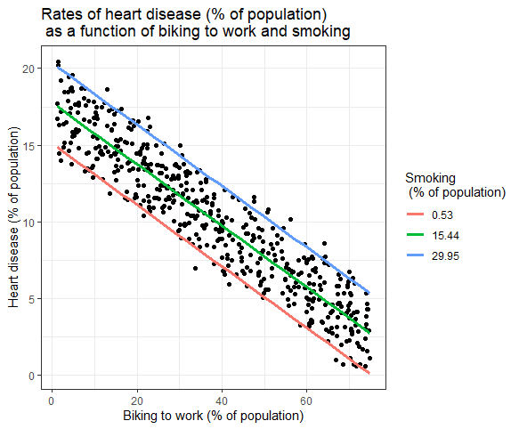
Because this graph has two regression coefficients, the stat_regline_equation() function won’t work here. But if we want to add our regression model to the graph, we can do so like this:

heart.plot + annotate(geom="text", x=30, y=1.75, label=" = 15 + (-0.2*biking) + (0.178*smoking)")

Step 6: Report your results
In addition to the graph, include a brief statement explaining the results of the regression model.
Reporting the results of multiple linear regression

In our survey of 500 towns, we found significant relationships between the frequency of biking to work and the frequency of heart disease and the frequency of smoking and frequency of heart disease (p < 0 and p<0.001, respectively).
Specifically, we found a 0.2% decrease (± 0.0014) in the frequency of heart disease for every 1% increase in biking, and a 0.178% increase (± 0.0035) in the frequency of heart disease for every 1% increase in smoking.

